Pin 8 - Ground
Pin 1 - Power
Pin 2 – Programming Input
Pin 3– Digital Input G3
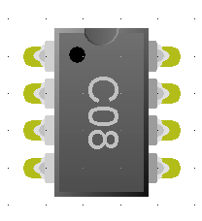
Pin 7 – Digital output G0 &
Status Output
Pin 6 – Digital Input/Output G1 or Analogue Input A1
Pin 5 – Digital Input/Output G2 or Analogue Input A2
Pin 3 – Digital Input/Output G4 or Analogue Input A4

Genie C08 Pin-out Diagram

